**TECHNO - DOMBAI ENGINEERING**

***Providing Excellent, Efficient and Cost Effective Engineering Solutions***

**Address: 16 Raymond Njoku Street, Off Awolowo Road, Ikoyi Lagos**

**Email:** [**info@techno-dombai.com.ng**](mailto:info@techno-dombai.com.ng) **; Website:** [**www.techno-dombai.com.ng**](http://www.techno-dombai.com.ng)

**Telephone: +2349083222250, +2348066565905**

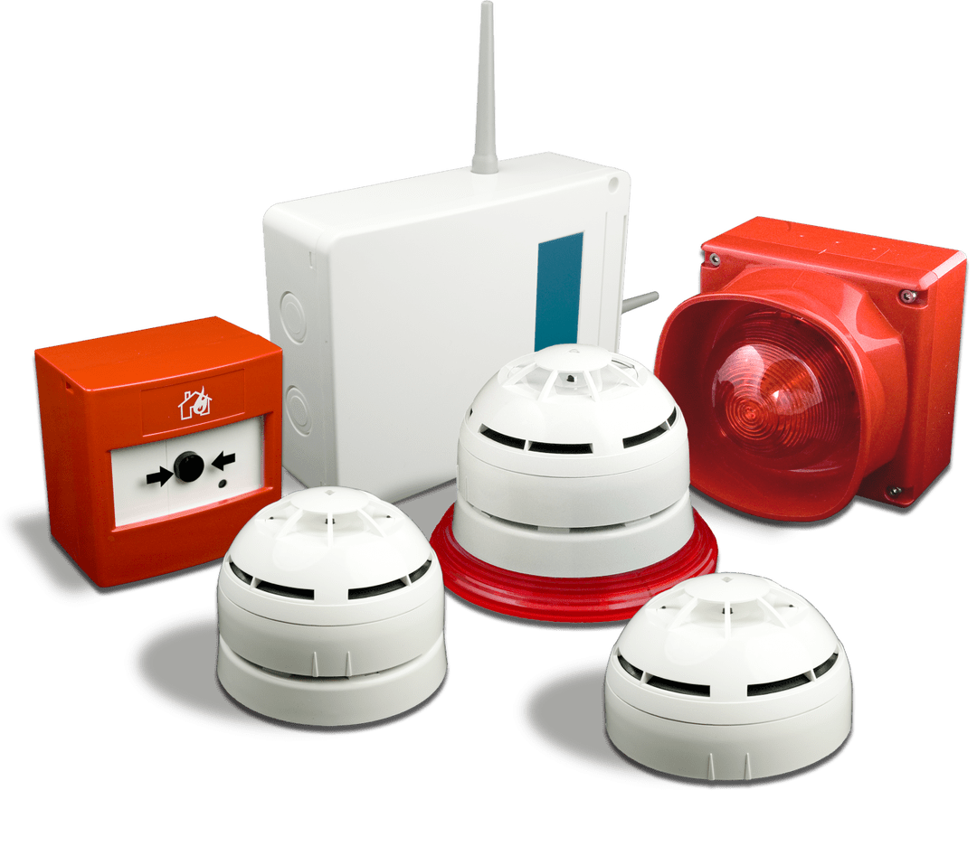

**FIRE SUPPRESSION EQUIPMENT MAINTENANCE CONTRACT BETWEEN UNIVERSITY OF SCIENCE AND TECHNOLOGY, ESUT ENUGU & TECHNO DOMBAI ENGINEERING.**

**A BRIEF BACKGROUND OF TECHNO DOMBAI ENTERPRISE:**

**Techno Dombai Engineering** Is an indigenous engineering firm whose primary objectives is to render mechanical and electrical installations and maintenance services in the oil and gas sector, upstream/downstream and facility management services.

Our a vast knowledge in M.E projects were gotten from taking parts in giant projects and managing high risers with modern facilities, amongst our clients are

* CBN
* Ladol Oil and Gas
* Total Oil and Gas
* Etco Electrical LTD
* Access Bank
* UBA
* GTB
* Mantrac LTD
* America tobacco Lagos
* Office of the Lagos State Surveyor General Alausa, Ikeja, Lagos
* AB Marine Offshore LTD to mention but a few.

You will find more about the people we work for in our complete engineering proposal for solutions to engineering problems which will be submitted alongside with this extract for fire suppression proposals, also therein is our core value, mission and vision statement, staff strength, organogram and goodwill services.

Having taking part in the CBN ESUT LAB PROJECT as a sub contractor under PRAISE CONSTRUCTION LTD, to install and power all the electrical alarm systems including:

Master blaster, sound flasher, fire alarm panel, break glass, smoke/heat dictators, etc and mechanical which comprises water sprinkler lines, water storage tank, fire hydrant pump, fire hose reels, sprinkler heads etc, we hereby tender our proposal to take on the maintenance and management of that segment of services in the laboratory facility, we are glad to install a maintenance engineer on site handed over to the University, considering the sensitivity of the lab, volatile chemicals and all that and the value of life and properties.

Listed below are quarterly and annual maintenance services to be rendered as per discussions and inspections carried out by our team.

**INTRODUCTION**

We wish to draw your attention to the ugly situations and memory fire has caused property owners and facility managers even after ensuring that fire fitting equipment is in place, it has robbed many of their happiness, precious things they really treasured, properties, valuables, investment and even life.

The occurrence of hazardous fire is an unforeseen circumstance that grows beyond Human control when it is left unchallenged. Numerous cases of fire incidents have left many in awe of its rate of destruction when it occurs.

This is not the case; however, there should be a routine process in place for all fire safety equipment maintenance periodic maintenance will help ensure that the equipment that is in place is ready to address a fire emergency.

Without the **PREVENTIVE MEASURE** ***(maintenance)*** the equipment can easily fall into disrepair or become broken.

So many factors such as dust, dirt accumulation, extreme heat or cold, vibrations from heavy machinery, excessive moisture and exposure to sunlight and even some human factors can make equipment malfunction

In all cases it is vital to carry out a review of your [***fire risk assessment***](http://www.firesafeservices.com.au/fire-safety-audit) to determine if any changes could impact the ability for your equipment to properly protect your facility. For instance, if you have added a new area or performed renovations, these would change your risk of fire; therefore a risk assessment as part of your fire safety equipment maintenance could help to determine this.

**SERVICE AND MAINTENANCE AGREEMENT**

These stipulated terms and conditions herein on this day 15th June, 2020 is proposed to be a binding agreement upon acceptance by client through endorsement, ***ENUGU STATE UNIVERSITY OF SCIENCE AND TECHNOLOGY, ESUT, ENUGU***  Herein after referred to as the “Client” and

***TECHNO DOMBAI ENTERPRISE***

Herein after referred to as the “Contractor” for the purpose of undertaking the services; Techno Dombai shall perform inspections and testing as identified in the current Fire Code of Federal Fire Service (**6/S.18/VII/907,  
2012).** **for the safety code to  be enforced  in all public buildings as  
contained in the Federal Government’s circular, Ref. No. SGF** for Water-Based Fire Protection Systems. Contract requirements include, but are not limited mechanical and electrical.

**MECHANICAL**

**Sprinkler heads:**

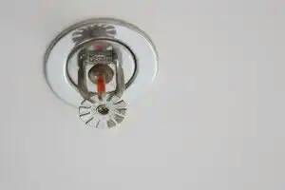 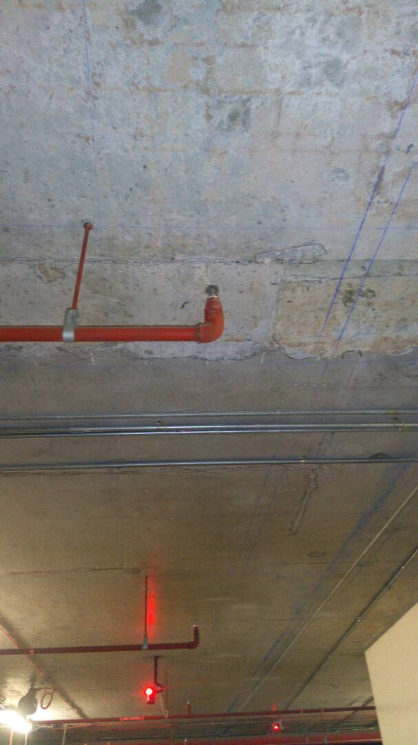

We visually inspect for any corrosion, physical damage, obstructions to spray pattern, check for sprinkler heads with any paint other than manufacturers, concealed covers, spare replacement heads, wrenches and storage cabinet.

**Control Valves**:

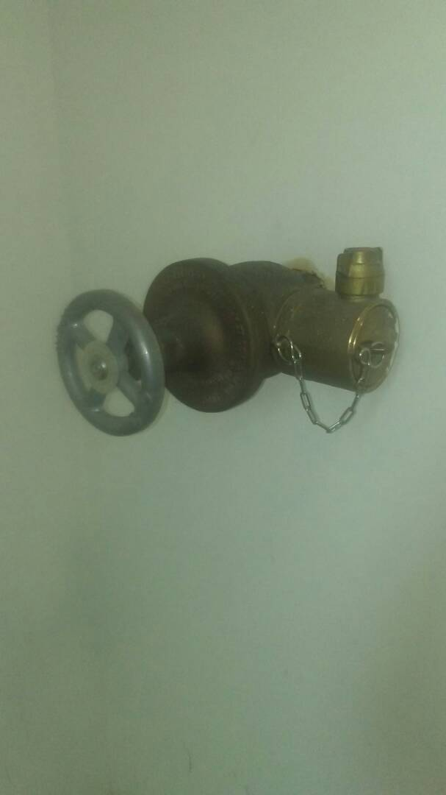

We will ensure that the valves are accessible and in the normally open or closed position, properly sealed, locked or supervised, free from external leaks and properly identified.

**Check valves:**

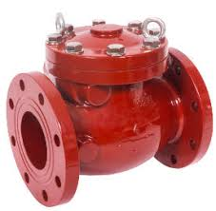 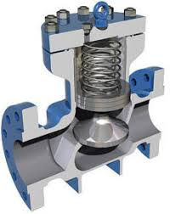

We will visually inspect the check valve to ensure they are free from leaks and verify direction of water flow.

**Backflow preventer:**

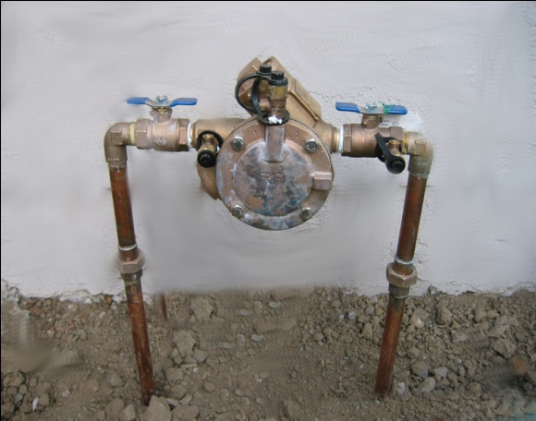

We will inspect for control valves open, relief port not discharging.

**Pressure regulating valves:**

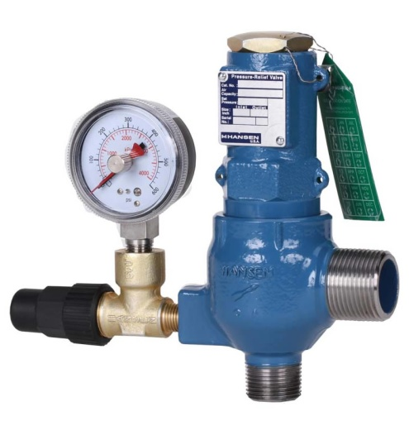

Verify that the valves are in the open position, not leaking and are maintaining downstream pressures in accordance with design criteria.

**Alarm Valves/System Riser Check Valves:**

Visually inspect, gauges reading properly, no damage, zero leakage, trim valves operational.

**Wet Pipe System:**

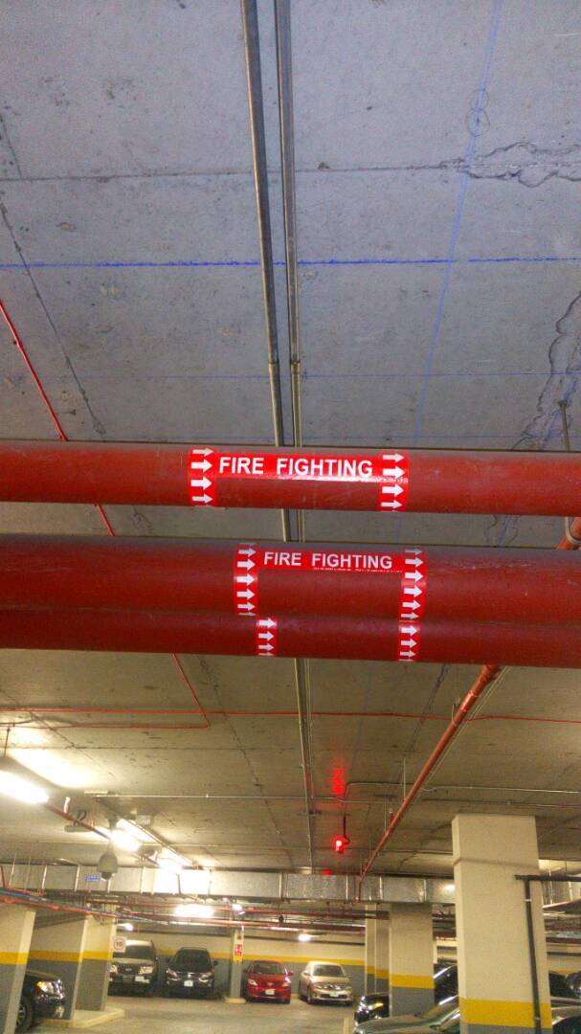

Test alarms by opening the inspector’s test connection. This simulates the flow of water from one sprinkler head and will activate the water motor alarm as well as the flow switch or pressure switch.

**Dry-Pipe Valves:**

Exterior inspected, trim valves operational, gauges, no leaks

**Pipe Work:**

Check for proper pitch, good condition, damage, no leaks or corrosion, hangers and braces properly attached.

**Dedicated Water Storage Tank(s):**

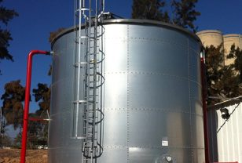

Verify water level, water supervision alarms, heating systems, water temperature, exterior of tank, paint or coatings, supporting structure, vents, foundation, ladders for damage or weakening , control valves, auto fill valves, pumps and air pressure in pressure tanks

**Sprinkler Fire Pumps:**

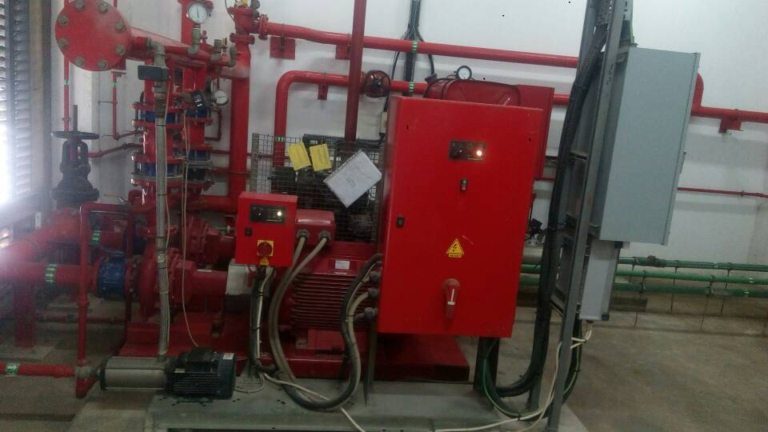

The scope of our maintenance services also involves ensuring that the pump assembly is in good operating condition and is free from physical damage; we will technically verify power source, control valves, electric motors, standby diesel engine and battery, electric control panel, jokey, pressure tank, temperature of pump room, no leaks, and ensure pressure gauges are correct.

**Fire Department Connections:**

Connections should be accessible and visible, caps or plugs in place, threads clean, undamaged and lightly lubricated with graphite. The connection is drained through the ball drip valve assuring it will not freeze. Hydraulic Nameplate – provided at riser, all information complete

[**Fire extinguishers**](http://www.firesafeservices.com.au/fire-extinguishers)**:**

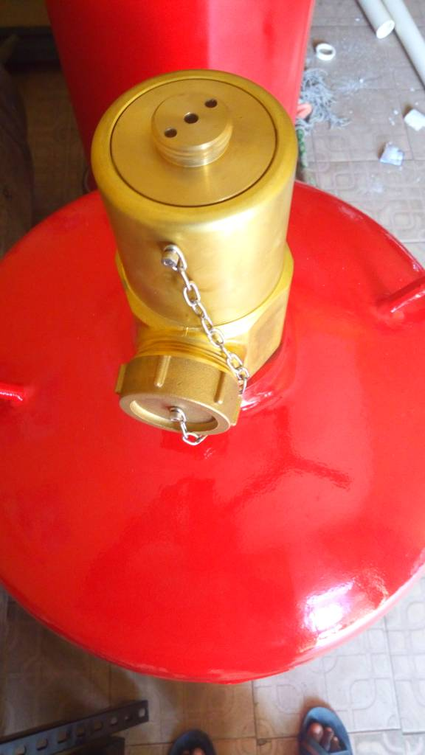

Inspect nozzles, hoses, container area for damage. Also check the charging gauge to make sure unit is charged. Check mounting brackets and note the inspection tag is current. Note the location of the extinguishers and whether they are placed appropriately to quickly address any potential fire risk areas.

[**Fire hydrants And Hose Reels**](http://www.firesafeservices.com.au/products/fire-hydrants-and-hose-reels):

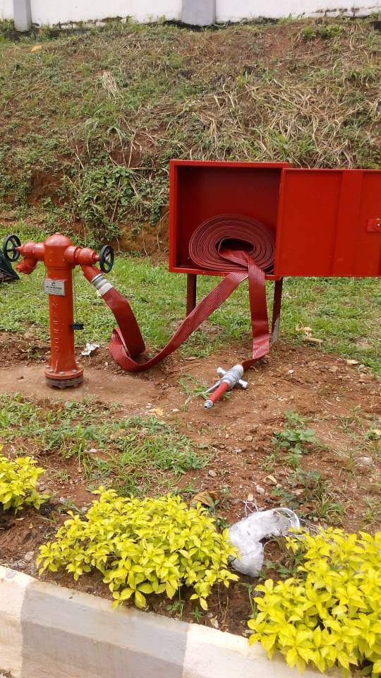

Check water pressure, check connections, inspect routing and ability to reach potential fire risk areas among other items. Confirm there are no obstructions or obstacles that may impact the ability for the hydrant to service the fire risk areas

**ELECTRICALS**

**Alarm Devices:**

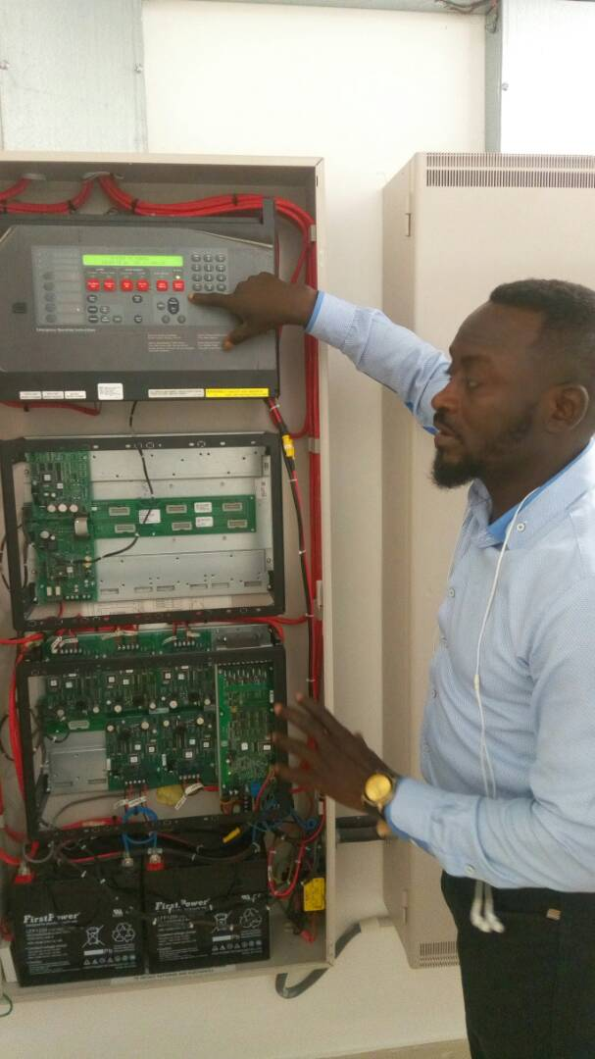

Water motor gongs, flow switches, tamper switches, and pressure switches shall be inspected for damage, during this inspection, we will ensure that all electrical connections are secured and the devices visually in good condition.

[**Emergency lighting**](http://www.firesafeservices.com.au/products/exit-and-emergency-lighting) **Inspection and Service:**

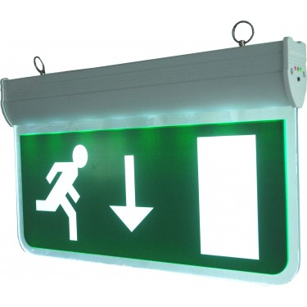

Inspect and confirm that battery backup is working properly, check electrical connections, test to make sure automatic lighting sensors will trigger properly and cover the assigned areas appropriately

[**Smoke detectors and fire alarms**](http://www.firesafeservices.com.au/products/residential-fire-products)

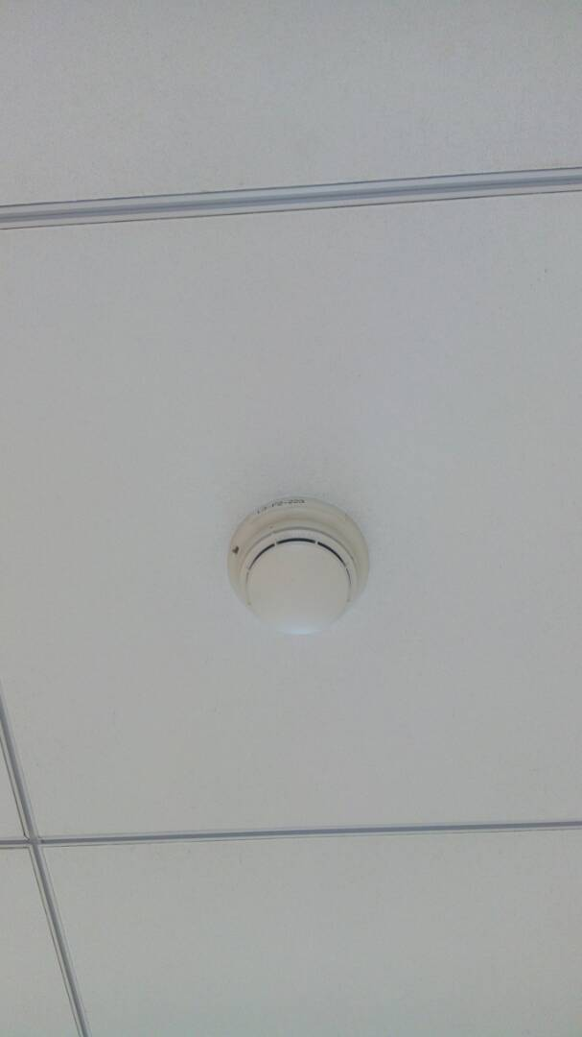

Confirm sensors are working properly, check battery backups if they are DC powered, confirm audible noise is adequate to alert occupants, confirm visual strobe or light is working properly, and confirm locations are appropriate to detect potential fires

**YOUR PACKAGE INCLUDES:**

* Regular inspections
* Inspect all the smoke detectors and heat detectors
* Manual call points
* Sounders and flasher
* Electric panels (Addressable / non-addressable)
* Fire pump’s electric motor and panel
* Sprinkler heads
* Fire hydrants
* Fire hose reels
* Fire extinguishers
* Fire symbols within work area, power house and muster point

The Service to be provided by virtue of this agreement shall commence on 25th January 2019 upon agreement and will be for an initial period of one (1) Year.

This implies three (3) quarters per annum, our services and maintenance shall be conducted once every quarter and report sent across accordingly to the appropriate authorities.

Kindly note that different level of services and maintenance shall be carried out subsequently after the first year, this will be communicated to you via email with pictures attached and any further affordable prove(s).

* **PAYMENT**

The Customer shall pay to the Contractor a sum of (**TO BE DISCUSSED WITH CLIENT UPON ACCEPTANCE OF OFFER**) per maintenance per quarter and total sum of (X-NAIRA ONLY) **#X :00** annually payable in advance. The price is strictly NET and inclusive of 7.5% value added tax (VAT).

**THE SERVICES TO BE PROVIDED**

* Preventive inspection & maintenance program
* Scheduled Service and Maintenance
* Major part replacement guarantee
* Quarterly report of the equipment’s status
* Water Quality Examinations and dedicated water tank cleaning service.

This is practically applicable to both electrical and mechanical gadgets as stipulated above

* **EXCLUSIONS**

The following activities are excluded from the scope of the services to be provided under this agreement:

* Cost of repair and Parts used for any repairs unless covered by under the product warranty of the seller.
* Supply of diesel for pump’s generator backup
* Supply and treatment of water to ensure zero salt content in other to avoid rapid corrosion and degradation of sprinkler pipe materials and dedicated water storage tank(s).
* Installation of fire marshal on site
* Installation of our maintenance team on site.

We will also make informed recommendations on FIRE EQUIPMENT MANAGEMENT (FEM) and use. We have a network through our supply chain partners who can provide all other parts (quality and acceptable standards) very rapidly. This ensures our clients can maximize their time and keep you focused on your business.

* **SITE**

Enugu State University Of Science And Technology, ESUT, Enugu, Agbani Main Campus, Enugu State, Nigeria

* **FREQUENCY OF VISITS**

(a) **Techno Dombai** shall send any of her Engineers at least once per month to carry out a visible inspection on the fire fighting gadgets and gather reports accordingly, approval and access in this regards should be made known to occupants and security guards.

(b) NB: If the Contractor is prevented by the Customer from inspecting the systems on the occasion of a visit, any further visit necessitated thereby will be charged as an addition to the Contract Sum.

Attendance between the Contractor’s regular visits is included within this agreement. Where parts are needed, the attached conditions will apply and subsequent visits to attend site will be subject to an additional charge at the Contractor’s normal rates.

**INVOICING/PAYMENTS**

**TECHNO - DOMBAI ENGINEERING**

***Providing Excellent, Efficient and Cost Effective Engineering Solutions***

**Address: 16 Raymond Njoku, Off Awolowo Road, Ikoyi Lagos**

**Email:** [**info@techno-dombai.com.ng**](mailto:info@techno-dombai.com.ng) **; Website:** [**www.techno-dombai.com.ng**](http://www.techno-dombai.com.ng)

**Telephone: +2349083222250, +2348066565905**

|  |  |  |
| --- | --- | --- |
| To:  Enugu State University Of Science And Technology, ESUT, Enugu. |  | DATE:  15th June, 2020 |
| DOCUMENT: Contract Agreement |
| Attention: (The Vice Chancellor) Prof. Charles Eze. | QUOTE No: ESUT –LAB 0001 |

**INVOICE FOR ANNUAL MAINTENANCE CONTRACT FOR FIRE FIGHTING EQUIPMENT**

|  |  |  |  |  |
| --- | --- | --- | --- | --- |
| **S/NO** | **JOB DESCRIPTION** | **QUANTITY** | **UNIT PRICE** | **TOTAL** |
| **1** | Staff/marshal’s Salary for 12 Months | 12 Months | - | - |
| **2** | **Annual Service & Maintenance Charge Payment For Pump Gen Set.** | 3 Quarters | :00 | :00 |
| **3** | **Mid Year Training To Be Conducted For Technicians On Site.** | 2 intensive training exercises. (every six months) | :00 | :00 |
| **4** | **Tips and Awareness Program** | 2 contacts per annum | **:00** | **:00** |
| **5** | **Professional Charge** | 3 servicing in 12 Months | :00 | :00 |
| **SUB TOTAL** | **:00** |
| **7.5% VAT** | **:00** |
| **TOTAL** | **:00** |

**TERMS & CONDITIONS**

|  |  |
| --- | --- |
| **VAT** | Prices are VAT Exclusive |
| **Payment Terms:** | All bank deposits and Transfers should be made into any of our Nominated Bank Accounts. ***ACCESS BANK: 0093179644 (TECHNO-DOMBAI)*** |

***Thank You for Your Patronage***

This AGREEMENT when signed by the Customer and the Contractor shall constitute the contract and all prior representations, correspondence and agreements shall thereby be superseded.

CONTRACTOR: ………………………………………………..

DATE: - - / - - / 2020; SIGN: ……………………………….

CLIENT: …………………………………………………………

DATE: - - / - - / 2020; SIGN: ……………………………….